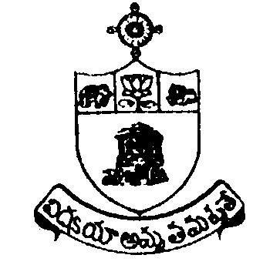SRI KRISHNADEVARAYA UNIVERSITY

NO DUES CERTIFICATE
(Non-Teaching Staff/Hostel Staff)
Name | Designation
 | Date of Superannuation
Prior intimation of the University (Memo No. of. Date)
Instructions

``No dues” issuing authority shall verify all the records before issuing No Dues Certificate to a retired employee

- ``No dues” shall not be issued subject to any kind of conditions by H.O.D
- Issuing authority shall sign only when incumbent clears all the dues to the university.
- Heads of the section shall bear responsibility for issuing any defect No Dues Certificate.

1. | Department /Section (Where Working) | :
2. | University Library | :
3. | Finance & Accounts Section | :
4. | Others, if any | :

I hereby undertake that in the event of any` dues’ comes to light at a later date, I will settle the dues amounts if any, I authorize the university to deduct such dues amount to the University from my retirement benefits. I have not suppressed any kind of dues pending to the University.

Date: Signature of the Employee
Place:

